CHAPTER-1 INTRODUCTION

INTRODUCTION

The Banana Leaf Disease Prediction project focuses on developing a machine learning model using Convolutional Neural Networks (CNNs) to detect and classify banana leaf diseases. The model aims to automatically identify whether a banana leaf is healthy or infected with diseases like Sigatoka or Xanthomonas. It utilizes a dataset of banana leaf images organized into three categories: Healthy, Sigatoka, and Xanthomonas.
The dataset is carefully preprocessed by resizing images to a consistent size of 224x224 pixels and converting them to grayscale to reduce computational complexity. Additionally, pixel values are rescaled to a range between 0 and 1 to improve the model's convergence. To prevent overfitting and enhance generalization, data augmentation techniques such as rotation, zooming, and flipping are applied to the training images.
The CNN model consists of several convolutional layers followed by max-pooling layers to extract relevant features from the images. These features are then classified into one of the three categories using dense layers, with a softmax activation function in the output layer to assign probabilities to each class. After training, the model's performance is evaluated using a confusion matrix to assess its accuracy in distinguishing between the classes. The final goal of the project is to provide an automated system that can aid farmers in the early detection of banana leaf diseases, helping to reduce manual inspections.

Concept of the Project
The concept of this project is to develop an automated system using machine learning techniques, specifically Convolutional Neural Networks (CNNs), to detect and classify banana leaf diseases. The system aims to assist farmers by accurately identifying whether a banana leaf is healthy or infected with specific diseases, such as Sigatoka or Xanthomonas. Early detection of these diseases is critical in preventing their spread and minimizing damage to banana crops, leading to improved yield and reduced reliance on chemical treatments.
The key features of the system include:

    - Disease Detection and Classification: The core functionality of the system is its ability to accurately detect and classify banana leaf diseases. It uses a Convolutional Neural Network (CNN) to distinguish between healthy banana leaves and those infected with diseases like Sigatoka or Xanthomonas, providing quick and reliable diagnoses.
    - Image Preprocessing and Augmentation: To improve model performance and generalization, the system preprocesses images by resizing them to a uniform size (224x224 pixels), converting them to grayscale, and rescaling pixel values. Additionally, data augmentation techniques such as rotation, flipping, and zooming are applied to increase the diversity of training images, preventing overfitting and enabling the model to recognize leaves in various conditions.
    - Real-time Prediction: Once trained, the system can process new leaf images in real time and predict the class of the leaf (Healthy, Sigatoka, or Xanthomonas). This feature allows farmers and agricultural experts to quickly assess the health of banana leaves without the need for manual inspection.

    - Confusion Matrix for Performance Evaluation: After training, the system evaluates its performance using a confusion matrix, which helps in assessing the accuracy of the model in classifying images into the correct categories. This provides insight into the model's strengths and weaknesses, guiding further improvements.
    - User-Friendly Interface: The system is designed to be user-friendly, allowing farmers or users with limited technical knowledge to upload images and receive predictions with minimal effort. The output includes clear indications of whether the leaf is healthy or infected with a specific disease, assisting in informed decision-making.

The purpose of this project is to develop an automated system using Convolutional Neural Networks (CNNs) to detect and classify banana leaf diseases, such as Sigatoka and Xanthomonas. It aims to assist farmers in early disease detection, enabling timely intervention. This can reduce crop damage, minimize pesticide use, and enhance plantation management. Ultimately, the system supports sustainable and efficient agricultural practices.

Background

Banana cultivation is crucial for global food security and the economy, especially in tropical regions. However, diseases like Sigatoka and Xanthomonas pose significant threats to banana crops, leading to reduced yields and economic losses. Traditional manual disease detection is time-consuming and prone to errors, making early detection difficult. With the advancement of machine learning, particularly Convolutional Neural Networks (CNNs), there is an opportunity to automate the detection and classification of these diseases from images, providing an efficient and accurate solution to improve banana crop management.
Despite the success of these platforms, the industry still faces significant challenges:
- Data Quality and Variability: The accuracy of machine learning models heavily depends on the quality and diversity of the training data. Variations in lighting, leaf appearance due to environmental conditions, and different stages of disease progression can make it difficult for models to generalize and perform accurately across all conditions.
- Scalability: While small-scale implementations of disease detection systems have shown promise, scaling these systems to large, diverse plantations remains a challenge. The model must handle a vast amount of image data in real time and work efficiently in diverse agricultural environments.
- Integration with Existing Agricultural Practices: For such systems to be truly effective, they need to be integrated seamlessly with farmers' existing agricultural practices. Many farmers may lack the technical expertise or resources to adopt these advanced technologies, and the systems must be designed to be user-friendly and accessible.
- Model Robustness: In real-world conditions, the system must be robust enough to handle variations in image quality, leaf shape, and disease symptoms, ensuring high accuracy even with imperfect inputs. Ensuring this robustness across different banana varieties and climates remains a significant hurdle.
- Cost of Implementation: While the technology is advancing, the cost of deploying such systems particularly in regions where resources are limited can be prohibitive. This could slow down the adoption rate, especially among small-scale farmers.
- Data Privacy and Security: In some regions, concerns about the privacy and security of agricultural data particularly when it involves cloud-based solutions can be a barrier to the adoption of these technologies.
Overcoming these challenges will require continuous improvements in data collection methods, model development, and technology accessibility, as well as close collaboration between technology developers, agricultural experts, and farmers.

Motivation
The motivation behind this project is to address the challenges faced by banana farmers due to diseases like Sigatoka and Xanthomonas, which significantly impact crop yield and farmers' livelihoods. Traditional manual disease detection is slow, error-prone, and often unable to identify issues early. By leveraging machine learning, specifically Convolutional Neural Networks (CNNs), this project aims to develop an automated, efficient, and accurate system for detecting and classifying banana leaf diseases. This will enable early intervention, reduce reliance on pesticides, and ultimately improve crop yield and sustainability, supporting farmers and promoting food security in banana-dependent regions.
The key motivations include:
    - Early Detection of Diseases: Detecting banana leaf diseases like Sigatoka and Xanthomonas early is crucial to preventing widespread damage. With automated systems based on machine learning, farmers can identify and address issues in their crops quickly, before they have a chance to severely impact yield. This helps in taking timely action to control the spread of diseases and reduce crop losses.
    - Reduction in Manual Labor: Traditional disease detection methods require manual inspection of banana leaves, which is not only time-consuming but also prone to human error. Automating this process through image classification using Convolutional Neural Networks (CNNs) allows for faster, more consistent disease diagnosis, freeing up farmers’ time for other critical tasks and reducing labor costs.
    - Minimizing Pesticide Use: Early disease detection leads to more targeted and efficient treatment, which reduces the need for excessive pesticide use. This supports sustainable farming practices by lowering the environmental impact of pesticides, improving soil health, and promoting eco-friendly crop management.
    - Improved Crop Management and Yield: By providing farmers with accurate disease predictions, the system can help optimize crop management strategies. Timely interventions and better disease management can lead to healthier banana plants, resulting in improved crop yield, better fruit quality, and greater overall farm profitability.
    - Cost-Effective and Scalable Solution: Implementing machine learning solutions, particularly CNNs, provides a cost-effective method of disease detection that can be scaled across large plantations. Once developed, the system can be easily adapted to various farm sizes and environments, making it accessible to farmers in both small and large-scale operations.
    - Promoting Sustainable Agricultural Practices: The ability to detect diseases early and accurately helps reduce the overuse of chemical treatments, fostering more sustainable agricultural practices. The system encourages environmentally responsible farming while maintaining high productivity, which is essential for ensuring food security and preserving ecosystems.

Problem Statement
The banana farming industry faces significant challenges in detecting and managing diseases such as Sigatoka and Xanthomonas, which can severely impact crop yield and quality. Traditional disease detection methods, which rely on manual inspection, are often time-consuming, prone to human error, and unable to detect diseases early enough to prevent widespread damage. Additionally, the lack of efficient, affordable tools for farmers, coupled with the over-reliance on pesticides, exacerbates the problem. To address these issues, there is a growing need for automated systems that can provide accurate, timely disease detection while reducing the environmental impact of farming practices.

Manual Disease Detection is Time-Consuming and Prone to Errors: Traditional methods of detecting diseases in banana crops, such as Sigatoka and Xanthomonas, rely on manual inspection, which is slow, subjective, and prone to human error.

Inadequate Disease Management Tools for Farmers: Many banana farmers lack efficient and affordable tools to detect and manage plant diseases, leading to delayed action and reliance on expensive or inaccurate methods.

High Cost and Environmental Impact of Pesticides: Late disease detection leads to excessive use of pesticides, increasing operational costs and harming the environment through soil degradation, water contamination, and harm to beneficial insects.

Limited Scalability of Current Disease Detection Methods: Current disease detection methods are often not scalable, limiting their effectiveness on large banana plantations and leading to inconsistent disease management practices.

Lack of Technological Integration in Agriculture: here is a gap in the integration of machine learning and AI-driven solutions in traditional farming practices, preventing the widespread adoption of automated disease detection systems.

Justification of Project Title

The title, "Banana Leaf Disease Prediction Using Convolutional Neural Networks (CNNs)," accurately represents the focus and objectives of the project. The term "Automated" emphasizes the goal of developing a system that can independently detect diseases in banana leaves, reducing the need for manual inspection. This automation aims to streamline the process, making it faster and more reliable, which is crucial for timely intervention in preventing the spread of diseases such as Sigatoka and Xanthomonas that affect banana crops.

The inclusion of "Convolutional Neural Networks (CNNs)" reflects the advanced machine learning approach utilized in the project. CNNs are specifically designed for image analysis and are ideal for tasks like detecting patterns in leaf images. By using CNNs, the project aims to accurately classify banana leaf diseases, providing a powerful tool for farmers to manage their crops more effectively and efficiently. This combination of automation and deep learning aligns with the growing need for precision agriculture technologies.

Objectives of the Project

The objectives of the Property Rental System are as follows:

- Develop an Automated Disease Detection System: Create an automated system that uses Convolutional Neural Networks (CNNs) to accurately detect and classify banana leaf diseases such as Sigatoka and Xanthomonas.

- Enable Early Disease Detection: Provide an efficient solution for the early identification of diseases, allowing farmers to take timely action and prevent the spread of infections.

- Reduce Dependence on Manual Inspections: Automate the disease detection process, reducing the need for labor-intensive and subjective manual inspections.

- Minimize Pesticide Usage: Enable more precise disease management, thereby reducing the overuse of pesticides and minimizing their environmental impact.

- Improve Crop Yield and Quality: Help farmers enhance the health of their crops by providing accurate and timely disease diagnosis, ultimately improving yield and quality.

- Support Sustainable Agriculture: Promote sustainable farming practices by enabling data-driven, precision agriculture for better disease management and reduced environmental harm.

CHAPTER-2 RELATED CONCEPTS

Comparative Analysis of Property Rental Systems

This section provides a detailed comparative analysis of prominent property rental platforms—Airbnb, Housing.com, Booking.com, and 99Acres—to highlight their features, limitations, and gaps. Understanding these existing systems' strengths and weaknesses helps in identifying areas of improvement for the development of a more efficient and user-friendly Property Rental System.

Airbnb

Features:

      - Variety of Accommodations: Includes homes, apartments, treehouses, boats, and other unique stays.
      - Detailed Property Listings: Each listing includes pricing, availability, amenities, and user reviews.
      - Secure Payments: Integrated payment system, ensuring payment is released only after the stay.
      - Instant Booking: Renters can confirm their stay immediately, without needing approval from the host.
      - Calendar Syncing: Hosts can sync calendars to avoid double bookings.

Limitations:

      - High Service Fees: Significant service charges for renters and commissions for property owners, increasing the total cost and reducing profitability.
      - Limited Customization for Hosts: Hosts have limited flexibility in pricing models or offering special deals.
      - Unpredictable Availability: Property availability can change quickly, especially during peak seasons, leading to cancellations or unavailability.
      - Regulatory Challenges: Some regions have imposed restrictions on short-term rentals, impacting the platform's viability in those areas.

Housing.com

Features:

      - Residential Property Listings: Focuses on apartments, houses, and shared accommodations for long-term rentals.
      - High-Quality Images: Listings feature clear, detailed images of properties.
      - Real-Time Availability Updates: Renters can easily find properties with up-to-date availability.
      - User-Friendly Search Filters: Allows search based on location, price, and amenities for informed decision-making.

Limitations:

      - Primarily Long-Term Rentals: Limited options for vacation or short- term rentals.
      - Limited Property Types: Primarily residential properties, fewer non- traditional rental options like vacation homes or unique stays.
      - Low Customization for Hosts: Property owners have limited flexibility in customizing listings or offers compared to other platforms.

Booking.com

Features:

      - Wide Range of Accommodations: Includes hotels, resorts, vacation homes, and other types of accommodations.
      - Instant Booking: Allows immediate booking of properties without needing approval from hosts.
      - Multiple Languages: Supports international users with multilingual support.
      - No Prepayment Requirement: Renters often have the option to book without paying upfront, depending on the property’s policy.

Limitations:

      - Focus on Commercial Properties: Primarily caters to larger hotels and established property owners rather than individual homeowners.

      - High Commission Fees: Property owners are charged commissions of 15-20%, reducing their earnings.
      - Limited Communication with Hosts: Renters and hosts have minimal interaction before booking, which may limit personalization and transparency.

99Acres

Features:

      - Real Estate Listings: Focuses on residential, commercial, and industrial properties.
      - Advanced Search Filters: Allows users to filter properties by price, location, and amenities.
      - Lead Generation for Professionals: Provides tools for agents and developers to generate leads and connect with potential buyers/renters.

Limitations:

      - No Integrated Payment or Booking System: Renters and property owners must handle payments and bookings separately, complicating the process.
      - Limited Short-Term Rental Options: Primarily focuses on long-term rentals and property sales, not suitable for short-term vacation rentals.
      - Limited Interaction Between Renters and Owners: Renters and owners have to rely on external communication methods, which may cause delays or confusion.

Limitations of Existing Systems

Several gaps exist across the existing property rental systems, which the
Property Rental System aims to address:

- Lack of Real-Time Availability Updates: Many systems do not offer real-time availability updates, leading to confusion, overbookings, or renters discovering that properties are unavailable after making a booking.
- Limited Support for Individual Property Owners: Platforms like Booking.com and OYO Rooms are more suited to commercial properties or large-scale landlords, leaving individual property owners with fewer options for listing and managing their properties.
- High Fees Associated with Popular Platforms: The high service fees charged by platforms like Airbnb and Booking.com can deter both property owners and renters. Property owners face reduced earnings, while renters are often forced to pay higher booking costs.
- Absence of Interactive Features Like Map Integration: Platforms like 99Acres and OYO Rooms lack the ability to integrate interactive maps, which are crucial for helping renters visualize property locations and assess their proximity to local amenities.
By addressing these limitations, the Property Rental System aims to provide a more efficient, user-friendly, and affordable solution for property management and rental.

Chapter-3 Software and Hardware
Requirements

Software Requirements
The software requirements for the Property Rental System encompass front- end and back-end technologies, databases, APIs, and tools for deployment and version control.

Frontend Technologies:

- HTML: Structures web pages and defines the layout and content of the user interface.
- CSS: Styles web pages by enhancing appearance with colors, fonts, and layouts.
- Bootstrap: Provides pre-designed UI components for responsive and device-compatible designs.
- JavaScript: Enables interactivity, such as real-time updates, dynamic content, and form validation.

Backend Technologies:

- Node.js: Executes server-side JavaScript for scalable, high- performance applications with asynchronous programming.
- Express.js: Simplifies server-side development by managing routing, HTTP requests, middleware, and creating RESTful APIs.

Database:

- MongoDB: A NoSQL database for storing user data, property listings, bookings, and transactions in a flexible, scalable format.

Authentication:

- Passport.js: Middleware for secure user authentication, supporting various strategies like OAuth and JWT. Ensures secure login, registration, and session management.

APIs:

- OpenStreetMap API: Integrates interactive maps for displaying property locations and nearby landmarks.
- Stripe API: Handles secure payment processing with support for various payment methods like credit cards and digital wallets.
- Cloudinary: Manages image uploads, storage, and optimization for property listings.

Email Service:

- NodeMailer: Sends automated emails for user registration, booking confirmations, and promotions.

Version Control and Deployment:

- GitHub: Facilitates collaboration, version tracking, and rollback of code changes.

Software Requirements Summary Table :

Category | Technology | Purpose
Frontend | HTML, CSS,  Bootstrap, JavaScript | Creating, styling, and adding interactivity to the user interface of  the Property Rental System.
Backend | Node.js, Express.js | Backend logic, server-side handling, and API creation for managing user  requests and data.
Database | MongoDB | Storing and managing user data, property listings, bookings, and  transactions.
Authentication | Passport.js | Secure user authentication, login,  and session management.
APIs | OpenStreetMap, Stripe, Cloudinary | Integration with map services, payment processing, and media  management.
Email Service | NodeMailer | Sending email notifications for user registration, bookings, and other  communications.
Version  Control | GitHub | Version control for collaboration  and code management.
Deployment | Hosting services (Heroku, AWS) | Cloud-based hosting platforms for deploying and managing the  Property Rental System.
Table 3.1

Hardware Requirements

The hardware requirements for the Property Rental System specify the minimum system specifications needed for development, testing, and deployment of the platform. These specifications ensure smooth functioning and efficient performance throughout the development lifecycle.
The hardware requirements ensure the smooth functioning of development, testing, and deployment.

Processor:

- Intel i5 or higher: Ensures efficient execution of development tools, backend operations, and API interactions.

Memory (RAM):

- 8GB or higher: Allows for seamless multi-tasking, including testing APIs, running backend processes, and handling database queries.

Storage:

- 256GB SSD or higher: Provides fast file access and ensures smooth performance for storing project files, databases, and logs.

Internet Connectivity:

- Stable connection: Required for accessing external APIs, cloud services, and managing online resources for testing and deployment.

Hardware Requirements Summary Table :

Component | Specification | Purpose
Processor | Intel i5 or higher | Efficient processing of development tools, backend logic, and multi-tasking for various system components.
Memory (RAM) | 8GB RAM or  higher | Handling multiple processes, testing APIs, running backend operations, and supporting complex queries.
Storage | 256GB SSD or  higher | Fast access to files, databases, and system logs, ensuring smooth performance during development.
Internet Connectivity | Stable internet connection | Accessing external APIs, cloud- based services, and managing online resources fortesting and  deployment.

Table 3.2

Chapter-4 Implementation Details

Algorithm (Pseudo Code)

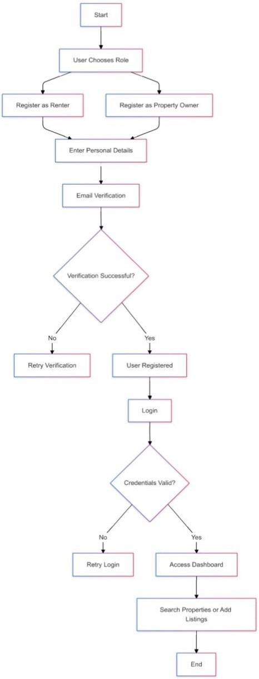

fig 4.1.1
User WorkFlow for Property Rental

In fig 4.2.3 The image shows flowchart that illustrates the user journey for the property rental website. It covers registration, email verification, login, and dashboard access based on the selected role (renter or property owner). Renters can search and book properties, while property owners can manage their listings. It ensures secure and role-based functionality.
The algorithm for implementing the Property Rental System is divided into two primary workflows: Backend Workflow and Frontend Workflow. Both workflows interact seamlessly to deliver the required functionalities, such as property listing management, booking processes, secure payments, and user authentication.

Backend Workflow:

The backend of the Property Rental System is built using Node.js and Express.js as the web framework. MongoDB is used as the database for storing user data, property listings, and bookings. The backend also integrates with third-party services such as Stripe for payment processing, OpenStreetMap for map integration, and Cloudinary for image handling.

Steps for Backend Workflow:

    - Initialize Node.js project and configure necessary dependencies.
      - Initialize a new Node.js project using npm init.
      - Install necessary dependencies like Express.js, Mongoose (for MongoDB integration), Passport.js (for authentication), body- parser, and others.

Setup MongoDB schemas for Users, Rentals, and Bookings.

      - Define MongoDB schemas for each collection. For example, the Users schema contains details about the renter or property owner, such as name, email, password, and user type (renter/owner).
      - Define a Rentals schema for property listings, including details like property name, address, price, description, and images.
      - The Bookings schema stores information about bookings, such as the booking date, user ID, rental ID, and payment status.

Develop API endpoints for CRUD operations and session management.
      - Create RESTful API endpoints to allow CRUD (Create, Read, Update, Delete) operations for properties, user profiles, and bookings. For example, routes to add, view, update, and delete property listings, view available properties, and make bookings.
      - Implement session management to track user login and authentication status using cookies or JWT (JSON Web Tokens).

Implement authentication and authorization using Passport.js.
      - Implement user authentication with Passport.js, including local strategy (username and password) for user login. Passport.js will ensure that only authorized users can access certain endpoints, such as adding or modifying listings.
      - Use Passport’s session management capabilities to handle persistent logins.

Integrate third-party APIs for maps, payments, and image handling.

      - Integrate the OpenStreetMap API to provide interactive maps for displaying the location of property listings.
      - Integrate the Stripe API to handle secure payments for bookings, ensuring that users can securely make payments online.
      - Use Cloudinary to upload and manage property images. Cloudinary provides image transformations such as resizing, cropping, and optimization.

Test API endpoints and backend logic using Postman.
      - Use Postman to test all API endpoints and ensure they return the correct data, handle errors gracefully, and provide secure functionality. For example, testing login routes, booking routes, and payment processing routes.

Backend Workflow Pseudo Code:

START
- Initialize Node.js project
- Install necessary dependencies
- Setup MongoDB schemas (Users, Rentals, Bookings)
- Create CRUD API routes for Rentals and Bookings
- Setup Passport.js for authentication
- Integrate OpenStreetMap API, Stripe API, and Cloudinary
- Test endpoints with Postman STOP

Frontend Workflow:

The frontend of the Property Rental System is built using HTML, CSS, Bootstrap, and JavaScript. The goal of the frontend is to deliver a user- friendly, responsive, and interactive interface. It will allow users to browse property listings, book rentals, view interactive maps, and make secure payments.

Steps for Frontend Workflow:

- Design responsive UI using HTML, CSS, and Bootstrap.
  - Create the basic structure of the user interface using HTML. Use Bootstrap to implement responsive grids and pre-designed components for a consistent design across devices.
  - The frontend will include pages such as the homepage, property listing page, property detail page, and user profile page.
  - Design the UI to be intuitive, with easy navigation, clear call-to- action buttons, and an overall engaging experience.

Add dynamic functionality using JavaScript.
  - Use JavaScript to add dynamic features to the frontend. This includes functionality such as filtering properties by location, price range, and type; displaying the details of a property dynamically when clicked; and updating the UI based on user interaction.
  - JavaScript will also be used to validate forms (e.g., user registration, booking) to ensure correct input and improve the user experience.

Connect frontend with backend APIs to fetch and display data.
  - Use AJAX or Fetch API to asynchronously call the backend API and retrieve data such as available properties, user profile information, and booking details.
  - Display property listings with images, descriptions, and a map showing the property’s location. Each property listing will have a link to a detailed view page where users can make a booking.
  - The frontend will also display real-time data like booking status and payment confirmations after users complete their transactions.
Frontend Workflow Pseudo Code:

START
- Design the structure of web pages using HTML
- Style the UI using CSS and Bootstrap
- Implement dynamic interactivity using JavaScript
- Integrate backend APIs to fetch and display property listings
- Ensure the UI is responsive across different screen sizes STOP

Features and Snapshots of Outputs
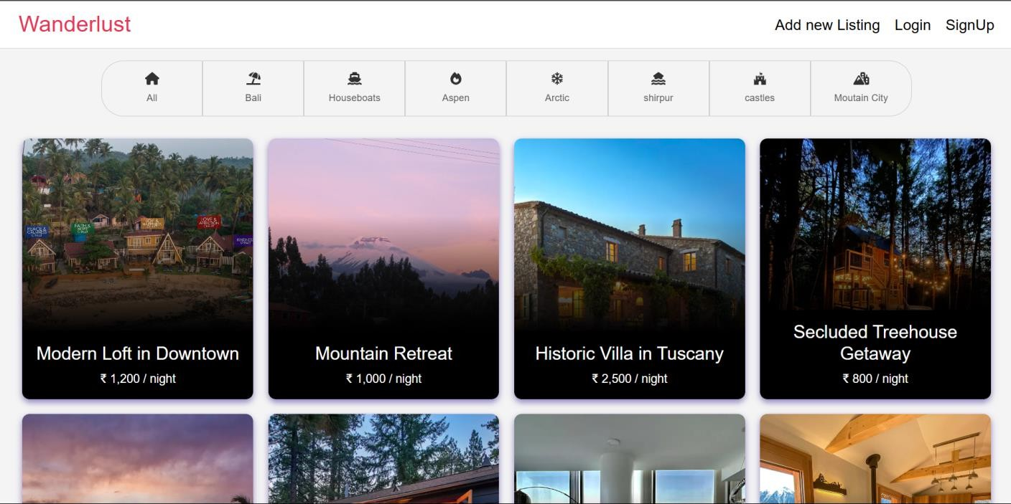

fig 4.2.1 Home Page
In fig 4.2.1 The image Displays all property listings in a grid format with images, basic details, and ratings to help users browse options.
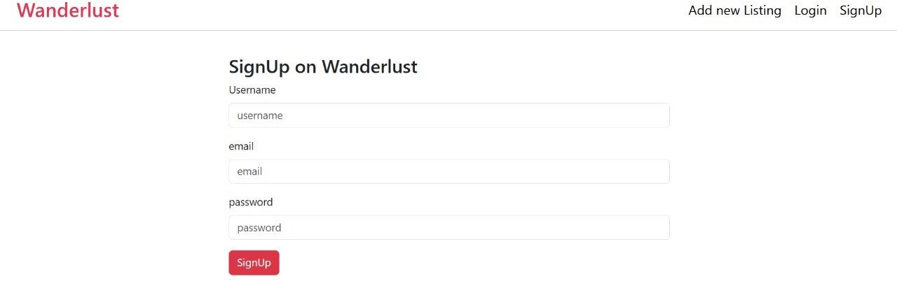

fig 4.2.2

Sign UP Page
In fig 4.2.2 The image shows Sign-Up Page : Lets new users create an account by providing details like name, email, and password. Sends a verification email using NodeMailer to confirm registration



fig 4.2.3 Login Page
In fig 4.2.3 The image shows Login Page : Allows users to log in securely using their email/username and password with Passport.js authentication. Includes a "Forgot Password" option for account recovery.

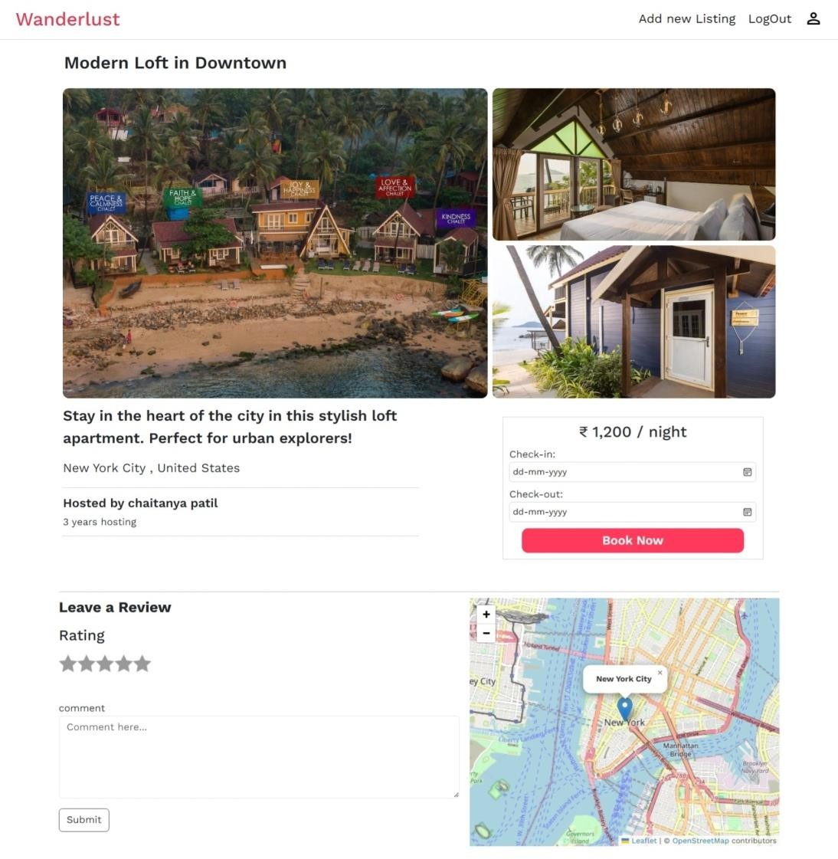

fig 4.2.4 User Profile Page
In fig 4.2.4 The image shows User Profile Page: Personalized dashboard showing user information, booked properties, and listings added by the user.

Visual Layout:

- The top section showcases user details.
- The middle section lists booked properties.
- The bottom section displays the user’s added listings, with action buttons like "Edit" or "Delete."

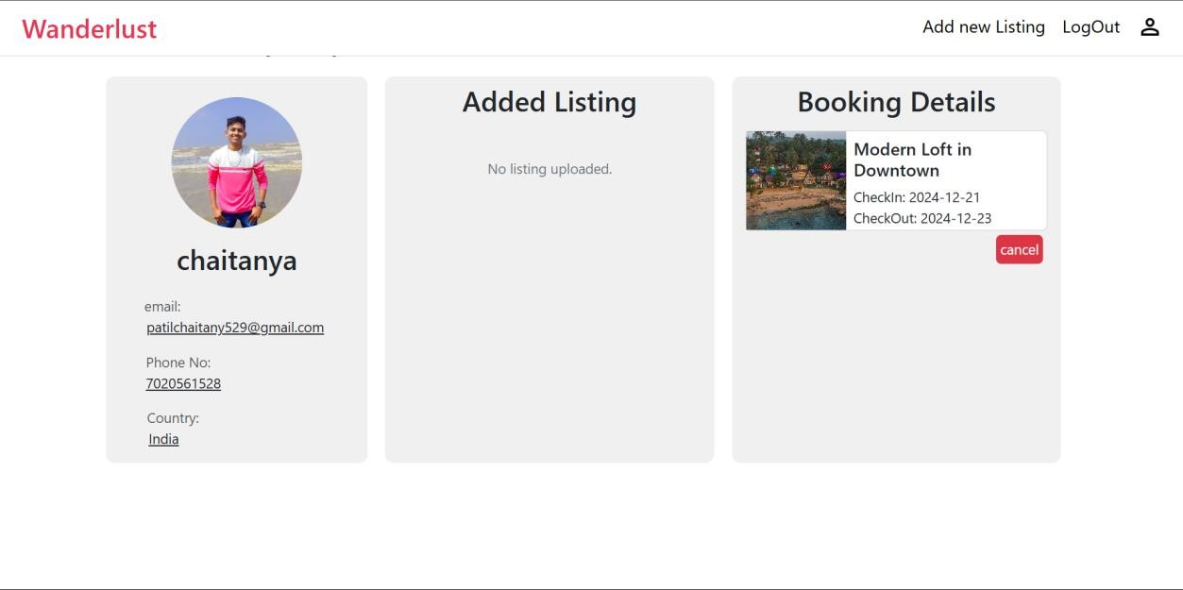

fig 4.2.5 Admin Profile Page
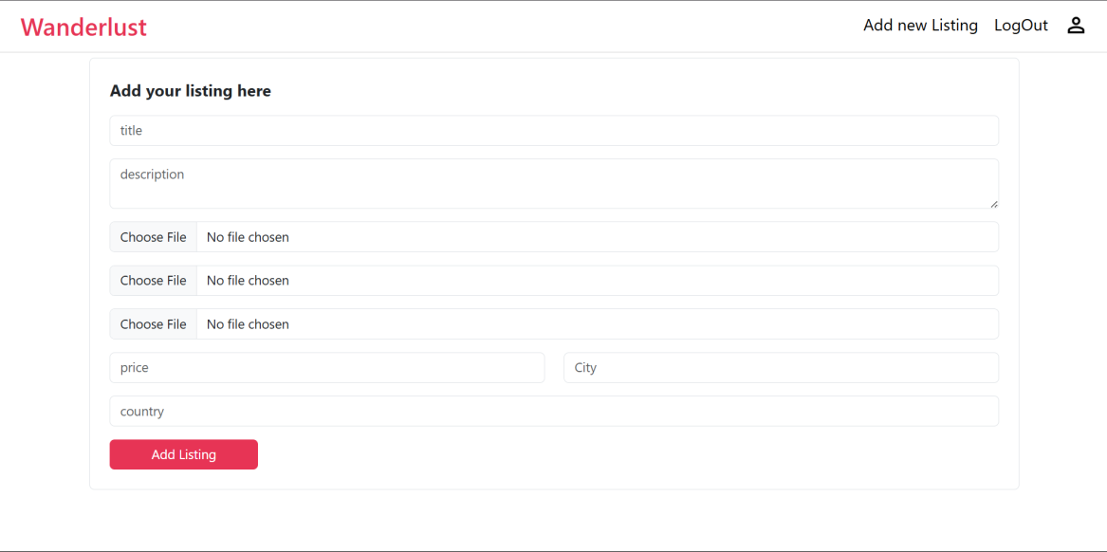

fig 4.2.6 Admin Feature
In fig 4.2.5 & fig 4.2.6 The image shows Admin Profile & Features: Allows admins to manage listings by adding, editing, or deleting properties to maintain up-to-date information.

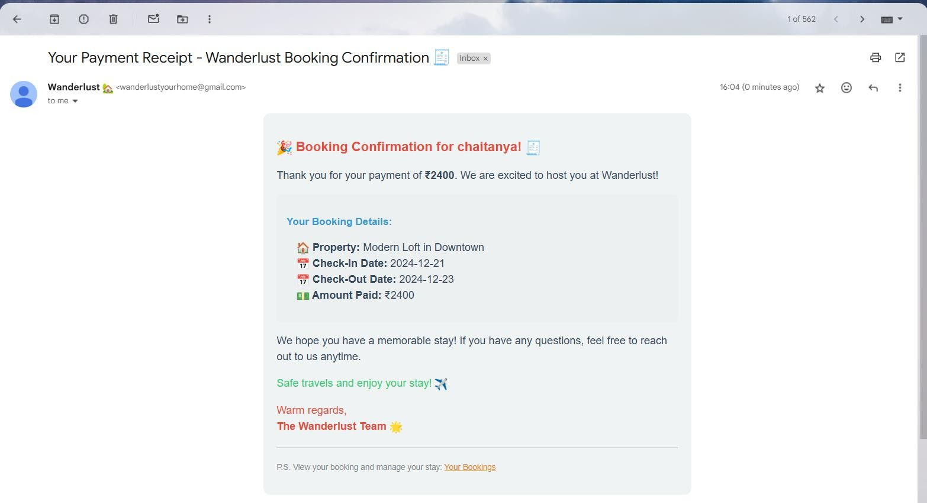

fig 4.2.7
Email Notifications Page

In fig 4.2.7 The image shows Email Notifications: Sends automated emails for signup confirmation and booking updates to keep users informed. The system incorporates automated email functionality using NodeMailer to maintain effective communication with users. These emails are triggered at specific events to keep users informed about their activities on the platform.The email notification system enhances user engagement and trust by keeping users informed and providing reliable communication.

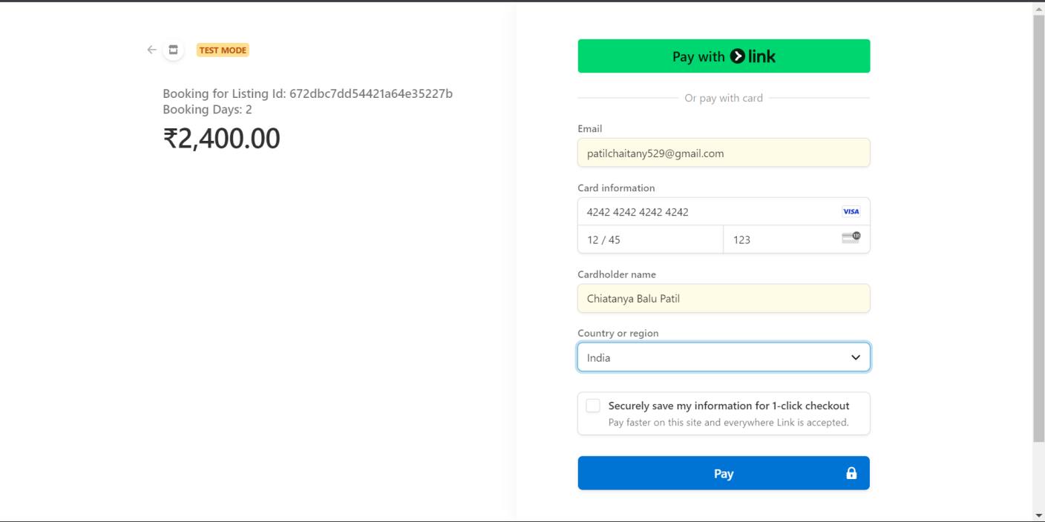

fig 4.2.8 Payment Gateway Page
In fig 4.2.8 The image shows Payment Gateway: Facilitates secure payments using Stripe API for booking transactions with a streamlined checkout process.

Result Discussion

The development of the Property Rental System was aimed at addressing several key challenges in the property rental industry, such as limited access to secure payment systems, lack of real-time availability updates, and inefficient user interfaces on existing platforms. The project was executed in such a way that it successfully met the project objectives and tackled the issues outlined in the problem statement. By focusing on creating a seamless, user-friendly platform for both property owners and renters, the project has significantly enhanced the overall property rental experience.

Methodology/Implementation

The Property Rental System was implemented in three distinct phases, each focusing on different components of the platform. These phases allowed for a structured approach to developing the system while ensuring that each feature was carefully integrated to meet the project’s objectives.

Phase I: Initial Setup and Basic Functionality

- Node.js and MongoDB Setup: Initialized a Node.js project with Express.js and MongoDB. Mongoose was used for MongoDB integration, creating schemas for Users, Properties, and Bookings.
- Basic Routes and Property Listings: Developed CRUD routes for property listings (create, update, view, delete). The frontend displayed property listings using HTML and JavaScript.
- Outcome: Established foundational backend and frontend functionalities for property listings, setting the stage for advanced features.

Phase II: Integration of Interactive Maps, Ratings, and Image Handling

- OpenStreetMap Integration: Used Leaflet.js and OpenStreetMap API to display property locations on interactive maps with custom markers showing property details.
- Session Management and Image Handling: Implemented user session management with Express-session for login persistence. Integrated Cloudinary for handling property images, allowing for cloud storage, resizing, and optimization.

- Ratings and Reviews: Added a rating system and review section for properties, allowing renters to rate and leave feedback, with restrictions on submissions for verified users.
- Outcome: Enhanced user experience with interactive maps, image handling, and ratings, preparing the platform for secure user authentication and payment functionality.

Phase III: Secure Authentication, Payments, and Email Notifications

- Passport.js Authentication: Implemented secure authentication with Passport.js using local strategy (email/password) and JWT for token- based authentication.
- Stripe Integration for Payments: Integrated Stripe for secure online payments, allowing renters to pay directly on the platform. Booking confirmation emails were sent after successful transactions.
- NodeMailer for Email Notifications: Automated email notifications for user registration, booking confirmations, and password resets.
- User Profiles and Enhanced Booking: Developed personalized user profile pages and enhanced booking features, including real-time booking availability and history tracking.
- Outcome: Successfully implemented secure authentication, payment processing, and email notifications, improving system security and user experience. Enhanced booking features allowed for better rental management.

Future Enhancements:

The system is designed to evolve and adapt to future needs. Some potential future enhancements include:
- Vehicle Listings: The platform could expand to include listings for vehicles, allowing users to rent cars, bikes, or other types of transportation along with their accommodations. This would provide users with a more complete travel experience.
- Chatbot Integration: A chatbot can be integrated into the platform to provide immediate assistance to users, answering questions about property availability, payments, booking status, and more. This will help improve user satisfaction by providing quick, automated responses.
- Real-Time Chat: Real-time messaging between renters and property owners could be added to facilitate communication, allowing users to ask questions and clarify details about properties directly through the platform.
- Recommendation for Local Spots: The system can suggest nearby attractions, restaurants, and activities based on a user’s booking and location. This feature will enhance the travel experience by offering personalized suggestions.
- Weather Integration: Integrating weather data for specific locations will help renters plan their stay better by giving them information about weather conditions at their destination.

Conclusion

The Property Rental System project has been a resounding success, achieving all the objectives set out in the problem statement. The system provides a comprehensive solution for the property rental industry, addressing key challenges such as secure payments, user authentication, and interactive property browsing. By leveraging technologies such as Node.js, MongoDB, Stripe, Passport.js, and OpenStreetMap, the platform was able to offer a feature-rich, secure, and user-friendly experience.This project is a valuable contribution to the property rental space as it simplifies and streamlines the process for both property owners and renters. Property owners now have an easy-to-use platform to list and manage their properties, while renters can easily search, explore, and securely book properties. The incorporation of automated email notifications and real-time payment processing enhances user engagement and ensures seamless transactions. Reflecting on the development process, the project has successfully integrated the core features that make property renting more convenient, efficient, and secure. The combination of responsive design, real- time map integration, secure payment handling, and robust user authentication ensures that the platform is competitive in the modern property rental space.

